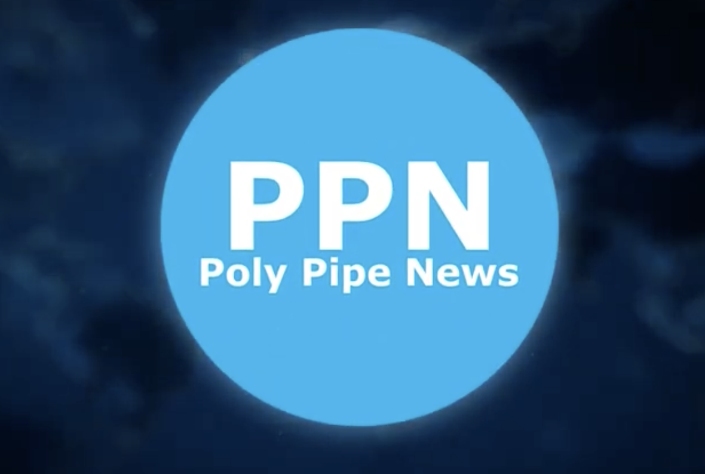
Examining the Role of Copper in Electrofusion Couplings: Implication
for PE100 Pipe Durability
PPN Special Report

High-density polyethylene (HDPE) pipes are widely used in irrigation, sewerage, and transmission pipelines for gas and potable water. PE100, a high-strength, lightweight HDPE material, is increasingly favoured for its excellent corrosion resistance and long service life. Designed to last a minimum of 50 years, PE100 pipes can withstand moderate pressure, high temperatures, and UV exposure, making them ideal for outdoor use. Electrofusion welding, a common technique for joining HDPE pipes, uses heat from resistive wire to create a permanent weld. However, copper resistive wires in these joints can accelerate HDPE’s natural aging process, risking premature failure.

The lack of literature on copper’s effect on HDPE degradation necessitates further research. This study assesses the impact of copper resistive wire within electrofusion joints on the long-term integrity of PE100 pipes. During the study, two types of HDPE samples, research-grade HDPE and commercial PE100 pipe, were artificially aged in an air-circulated oven to accelerate the degradation process. FTIR results revealed that copper influenced the degradation response of both HDPE samples.

The research showed that research-grade HDPE is more susceptible to copper-catalysed degradation than commercial PE100. However, no significant oxidative degradation was detected in copper-containing electrofusion joints.

By Ting Chong Chen
Ting embarked on his research journey in 2016 as a traineeship student at the Material Engineering Group within the Future Industries Institute (FII) at the University of South Australia (UniSA). His work with conducting polymer fabrication for thin-film coating technology ignited a deep passion for research and polymer science. He furthered his academic pursuits, completing a BSc (Honours) in 2018 and earning a First Class for his continuing research on conducting polymer fabrication. In 2020, Ting started his PhD candidature with SEAM, which at the University of South Australia Node is part of the Material Engineering Group at the Future Industries Institute. Under Professor Nikki Stanford’s guidance, Ting collaborated with Santos on an industrial project investigating copper poisoning in HDPE pipes. He successfully passed his oral defence in January 2024 and is now awaiting conferring in July.

