How Geotextile Bags and Tubes are Cleaning Up the Earth

By GNA Editor

Geotextile bags and tubes are emerging as powerful tools in environmental remediation and protection efforts worldwide. These innovative containment systems are playing a crucial role in cleaning up contaminated sites, managing sediment, and controlling invasive species. By effectively trapping and isolating pollutants and unwanted materials, geotextile solutions are helping to restore ecosystems and prevent further environmental damage.

Containing Contamination and Sediment

One of the primary ways geotextile bags and tubes are making a positive impact is through the containment and removal of contaminated sediment and sludge from water bodies. For example:

• In the UK, a major lake clean-up project utilized geotextile bags to remove and dry 17,000 tonnes of sediment. This not only improved water quality but also helped control an invasive aquatic plant species.

• In Turkey, geotextile tubes were employed to clean up a massive 57-hectare area in the Gulf of Izmit, freeing the bay bottom from accumulated mud and pollutants.

• In Melbourne, Australia, geotextile bags are being used to capture and contain road-derived sediment (RDS) in interceptor ponds, preventing these pollutants from entering waterways.

Advantages of Geotextile Containment Systems

Geotextile bags and tubes offer several key benefits for environmental remediation:

1. Effective containment: The permeable fabric allows water to drain while trapping solid particles and contaminants.

2. Versatility: Can be used in various environments including lakes, coastal areas, and industrial sites.
3. Cost-effective: Often less expensive than traditional dredging and disposal methods.

4. Reduced environmental impact: Minimizes the spread of contaminants during clean-up operations.

5. Invasive species control: Can help eradicate problematic plants by preventing photosynthesis during the dewatering process.

Success Stories

The clean-up of Stover Lake in the UK demonstrates the multi-faceted benefits of geotextile bags. Not only did they facilitate the removal of 17,000 tonnes of sediment, but they also played a crucial role in containing and eradicating the invasive New Zealand pygmyweed. By trapping the plant material and preventing photosynthesis, the geotextile bags ensured the invasive species would die off during the sediment drying process.

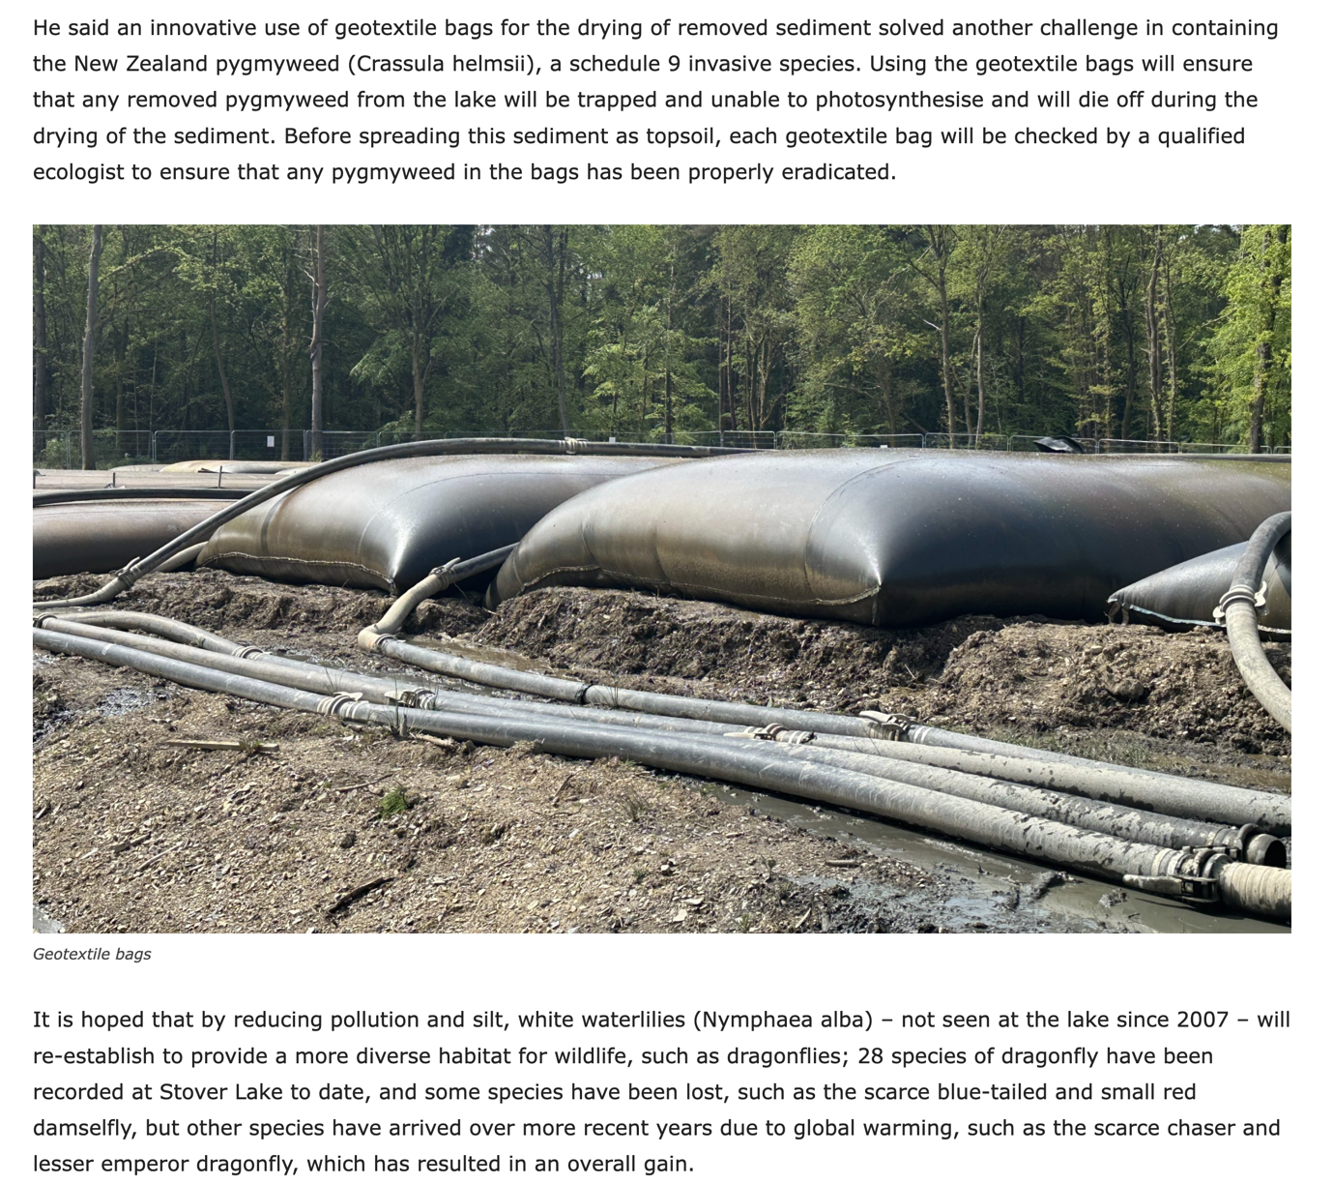

In the Gulf of Izmit, the use of geotextile tubes allowed for the efficient removal of mud and pollutants from a vast area of the bay. This large-scale clean-up effort has significant implications for the restoration of marine ecosystems and improvement of water quality in the region.

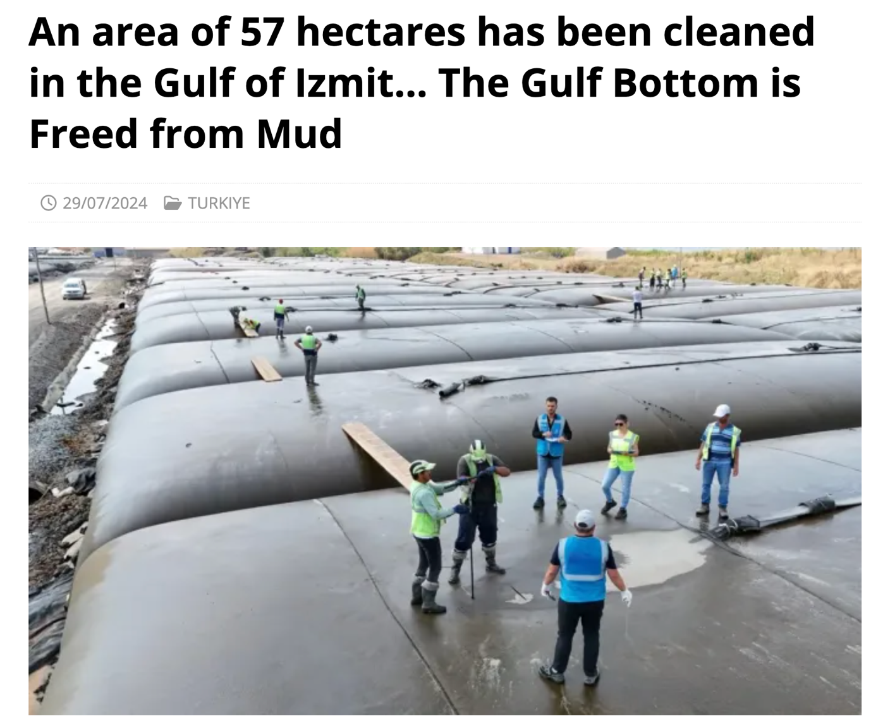

Future Potential

As environmental challenges continue to grow, the applications for geotextile containment systems are likely to expand. Potential future uses include:

• Coastal protection and erosion control

• Remediation of contaminated industrial sites

• Management of agricultural runoff and waste

• Habitat restoration in wetlands and estuaries

By providing an effective means to contain and manage contamination, sediment, and invasive species, geotextile bags and tubes are proving to be valuable tools in the ongoing effort to protect and restore our planet's ecosystems. As technology advances and implementation becomes more widespread, these innovative solutions have the potential to play an increasingly important role in environmental conservation and remediation efforts around the world.

