**Assessing and Ranking Performance of Protective Coatings in LNG and Oil & Gas Using Impedance Spectroscopy**

**By PCN Editor**

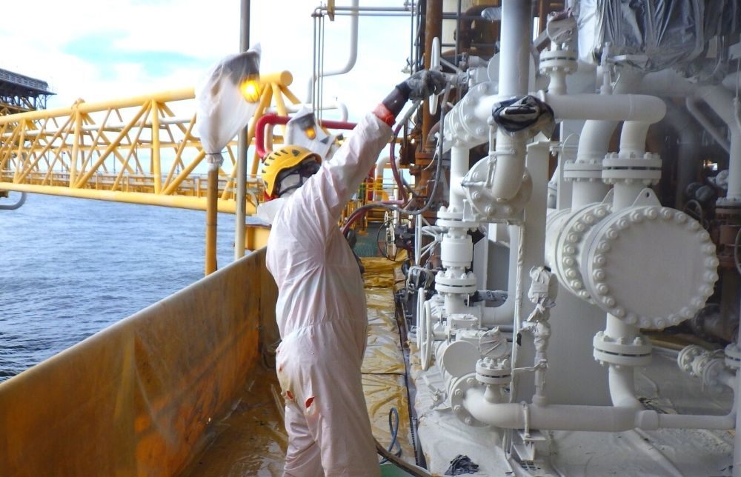

Protective coatings are crucial in industries like oil & gas, LNG and mining. They protect surfaces from corrosion, wear, and environmental damage. These coatings extend material lifespans, reduce maintenance costs, and ensure the safety and reliability of critical components. As industries advance material performance, the need for advanced coating evaluation techniques has grown.

Electrochemical impedance spectroscopy (EIS) has emerged as a powerful, non-destructive method for evaluating the electrochemical properties, performance, durability, and protective capabilities of coatings with unprecedented accuracy.

This article explores recent innovations in using impedance spectroscopy for coating evaluation, highlighting its growing importance in ensuring the longevity and performance of coated materials across various sectors.

***Principles of Impedance Spectroscopy***

Electrochemical impedance spectroscopy (EIS) works by applying a small alternating current (AC) voltage to a coated sample across a range of frequencies and measuring the resulting electrical current. The ratio of the applied voltage to the current defines the impedance, which varies depending on the coating's structure and properties.

Unlike direct current (DC) resistance measurements, EIS provides a frequency-dependent response that can distinguish between different electrochemical processes within the coating system. This ability to separate various contributions to the overall impedance makes EIS an exceptionally powerful tool for coating analysis.

Key parameters in EIS for coating evaluation include:

1. Impedance magnitude (|Z|): This parameter indicates the coating's resistance to current flow, with higher values suggesting better corrosion protection.
2. Phase angle: It reflects the capacitive or resistive nature of the coating; changes may indicate degradation or electrolyte penetration.
3. Coating capacitance (Cc): This relates to dielectric properties and thickness, signaling water uptake or deterioration.
4. Pore resistance (Rpo): It provides insights into coating degradation and pore formation, indicating pathways for corrosive substances to reach the substrate.

These measurements are typically presented as Nyquist plots, which graph the imaginary part of impedance against the real part to visualize the coating's electrochemical behaviour, and Bode plots, which display impedance magnitude and phase angle versus frequency to offer a comprehensive view of the coating's response across different timescales.

Interpreting these plots allows for a detailed analysis of coating performance, including assessing barrier properties, detecting defects, and predicting long-term durability.1,2

***Recent Innovations in Coating Evaluation***

Portable Impedance Sensors for Coating Failure Diagnosis

One of the most significant recent innovations in EIS for coating evaluation is the development of portable, miniaturized impedance sensors. These devices integrate microelectronics with EIS technology, allowing on-site coating evaluation.

A study published in the [*Journal of Coatings Technology and Research*](https://doi.org/10.1007/s11998-018-0072-5) designed a miniature impedance sensor for on-field diagnosis of early coating failure. The sensor was used to study the aging process of polyurethane-based coatings in a salt spray test chamber, focusing on critical EIS parameters such as specific capacitance, breakpoint frequency, phase angle, and impedance modulus.

The results demonstrated the sensor's capability to accurately monitor coating degradation, identifying thresholds such as impedance modulus below 106 Ω cm2 or phase angle less than 20 °, indicating complete coating failure in protecting metal substrates.

This innovative electrochemical sensor and portable analyzer offer enhanced sensitivity compared to conventional methods, facilitating on-site evaluation of coating degradation in practical environmental conditions.3

ML-Driven Impedance Analysis of Protective Coatings

Another cutting-edge development is the integration of machine learning algorithms with EIS to analyze coatings under complex conditions.

A study published in [*Construction and Building Materials*](https://doi.org/10.1016/j.conbuildmat.2020.118562) evaluated coatings exposed to stray current leakage in subway systems, a significant cause of accelerated corrosion in urban infrastructure. The researchers combined EIS with machine learning algorithms to predict impedance characteristics during corrosion.

They used equivalent circuit modelling to fit the Nyquist and Bode plots and developed an artificial neural network (ANN) to predict these plots during corrosion. The ANN model accurately replicated the Nyquist plot, demonstrating its potential for analyzing the equivalent electrical circuit of the corrosion system.

The integration of EIS and machine learning represents a promising approach for advanced analysis of coating performance, providing a practical method to enhance coating evaluation and mitigate corrosion risks in complex infrastructure systems.4

Using EIS to Develop and Assess Eco-Friendly, Self-Healable Coatings

As environmental concerns drive the development of more sustainable coating technologies, EIS is crucial in evaluating eco-friendly alternatives to traditional toxic coatings.

A study in [*Progress in Organic Coatings*](https://doi.org/10.1016/j.porgcoat.2022.107402) examined water-based acrylic and solvent-based epoxy resins as potential chromate coating replacements, posing significant toxicity risks. The researchers conducted EIS evaluations on these coatings, applied with and without zinc/aluminium pigments, on galvanized steel plates.

EIS provided detailed insights into the coatings' impedance characteristics, directly correlating with their ability to protect against corrosion. It helped distinguish between epoxy coatings, which showed complete detachment under impact testing, and acrylic coatings, which exhibited minimal cracking, highlighting the efficacy of EIS in identifying viable alternatives based on their electrochemical performance.

Furthermore, the researchers used EIS to assess the self-healing properties of these coatings, monitor impedance changes to evaluate the effectiveness of autonomous repair mechanisms, and refine formulations for improved durability and longevity.5

***Applications across Industries***

EIS's versatility and non-destructive nature have led to its widespread adoption across various industries for coating evaluation.

***Quality Control in Coating Manufacturing***

During the production of protective coatings, EIS serves as a non-destructive testing method to assess coating integrity, thickness, and protective properties. It helps detect microscopic defects and inconsistencies, ensuring each batch meets quality standards.

Moreover, EIS aids in formulating advanced coating materials by analyzing the effects of additives and composition changes on electrochemical properties, resulting in the development of more resilient coatings that resist corrosion, chemical degradation, and environmental damage.6

Marine, Automotive, and Aerospace Sectors

EIS has become essential in industries where corrosion threatens safety and structural integrity. It detects early coating degradation in marine environments, aids in developing durable automotive coatings, and evaluates aerospace coatings for durability, adhesion, and resilience against extreme conditions, reducing maintenance costs.7,8

Coating Assessment in Metallic Heritage Preservation

EIS has been widely employed for nearly three decades to assess the anti-corrosive properties of metal coatings, but its use in evaluating coatings for the conservation of metallic cultural heritage emerged much later, starting in the late 20th century.

Since then, EIS has gained popularity for testing coatings on materials like bronze, iron, silver, and lead, adapting its methodology to meet the unique requirements of heritage artifacts and conservation professionals.

It has proven invaluable in aiding conservators and restorers in selecting suitable coatings, whether applied to specially prepared samples or directly on artifacts to assess protective qualities or natural/artificial patinas.9

***Future Outlook***

Advancements in EIS technology are expected to enhance sensor miniaturization, speed up measurements, integrate machine learning for advanced data analysis, and explore applications in smart coatings with self-healing or sensing capabilities.

As EIS continues to prove its value in coating evaluation, it is expected to play an increasingly important role in shaping industry standards and practices. This may lead to more stringent quality control measures, improved coating formulations, and more accurate predictions of coating lifespan in various applications.5,10

***References and Further Reading***

1. Waters, N., Connolly, R., Brown, D., Laskowski, B. (2014, September). Electrochemical impedance spectroscopy for coating evaluation using a micro sensor. In *Annual Conference of the PHM Society*. [doi.org/10.36001/phmconf.2014.v6i1.2340](https://doi.org/10.36001/phmconf.2014.v6i1.2340)
2. Han, Le. (2019). *Impedance Spectroscopy*. [Online] LibreTexts. Available at: <https://chem.libretexts.org/Courses/Franklin_and_Marshall_College/Introduction_to_Materials_Characterization__CHM_412_Collaborative_Text/Electrochemistry/Impedance_Spectroscopy>
3. Cai, G., Wang, H., Jiang, D., Dong, Z. (2018). Impedance sensor for the early failure diagnosis of organic coatings. *Journal of Coatings Technology and Research*. [doi.org/10.1007/s11998-018-0072-5](https://doi.org/10.1007/s11998-018-0072-5)
4. Wang, C., Li, W., Wang, Y., Yang, X., Xu, S. (2020). Study of electrochemical corrosion on Q235A steel under stray current excitation using combined analysis by electrochemical impedance spectroscopy and artificial neural network. *Construction and Building Materials*. [doi.org/10.1016/j.conbuildmat.2020.118562](https://doi.org/10.1016/j.conbuildmat.2020.118562)
5. Abolhasani, H., Farzi, G., Davoodi, A., Vakili-Azghandi, M., Das, O., Neisiany, R. E. (2023). Development of self-healable acrylic water-based environmental-friendly coating as an alternative to chromates coatings. *Progress in Organic Coatings*. [doi.org/10.1016/j.porgcoat.2022.107402](https://doi.org/10.1016/j.porgcoat.2022.107402)
6. Margarit-Mattos, ICP. (2020). EIS and organic coatings performance: Revisiting some key points. *Electrochimica Acta*. [doi.org/10.1016/j.electacta.2020.136725](https://doi.org/10.1016/j.electacta.2020.136725)
7. Yang, HQ., Zhang, Q., Li, YM., Liu, G., Huang, Y. (2021). Effects of immersion temperature on the performance of a marine epoxy-based organic coating for ballast tanks. *Journal of Materials Engineering and Performance*. [doi.org/10.1007/s11665-021-05714-3](https://doi.org/10.1007/s11665-021-05714-3)
8. Suay, JJ., Rodrı́guez, MT., Razzaq, KA., Carpio, JJ., Saura, J. J. (2003). The evaluation of anti-corrosive automotive epoxy coatings by means of electrochemical impedance spectroscopy. *Progress in Organic Coatings*. [doi.org/10.1016/S0300-9440(02)00219-9](https://doi.org/10.1016/S0300-9440(02)00219-9)
9. Cano, E., Lafuente, D., Bastidas, DM. (2010). Use of EIS for the evaluation of the protective properties of coatings for metallic cultural heritage: a review. *J Solid State Electrochem*. [doi.org/10.1007/s10008-009-0902-6](https://doi.org/10.1007/s10008-009-0902-6)
10. Balasubramani, V., Sridhar, TM. (2023). Machine Learning in Impedance-Based Sensors. In *Machine Learning for Advanced Functional Materials*. [doi.org/10.1007/978-981-99-0393-1_12](https://doi.org/10.1007/978-981-99-0393-1_12)

--