‘Will Consult for Food’ - Boyd Ramsey

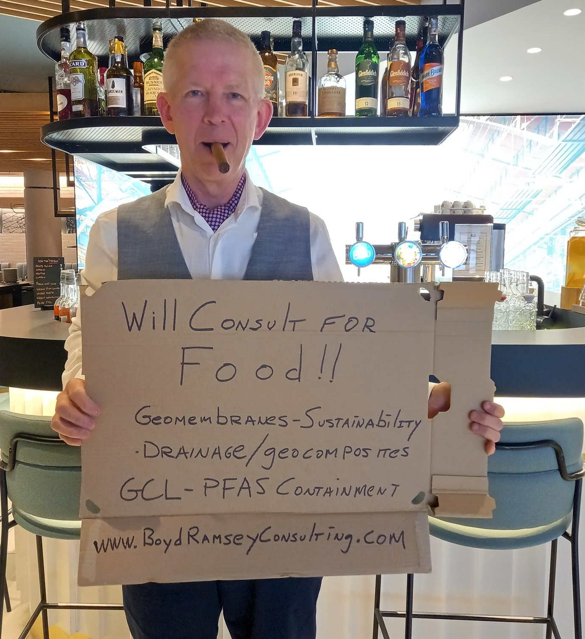

I will consult for food….well, actually for money, but I promise to use the money to buy food! Assuming declining covid and open borders, I will be coming to Australia for a long visit, June 1 to July 15. I already have a plane ticket.

The primary purpose is to attend the IGS Australasian chapters conference event, GeoANZ #1 (link here ), in Brisbane June 7-9th, I would encourage you to attend. But in addition to that I offer geomembrane and geosynthetics expertise on a more specific basis. I am available for educational presentations, updates on the latest activities in geosynthetics and site visits. I can help you solve and understand your geosynthetic issues and problems.

My website is listed below, in case you wish to learn more about me. I would love to hear from you and look forward to seeing you’all in person and meeting people again!

Best regards, wear the masks and be safe.

Boyd

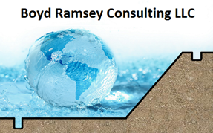
www.boydramseyconsulting.com
Phone +1 28 17 97 61 83

