**Discover Australia's Only Locally Made Geomembrane Aquamark®**

**27 May 2024**

Australia's only locally made geomembrane that ticks all the boxes for quality, performance, and reliability. Manufactured by GALE Pacific, Aquamark® is designed to meet the rigorous demands of various containment and storage applications.

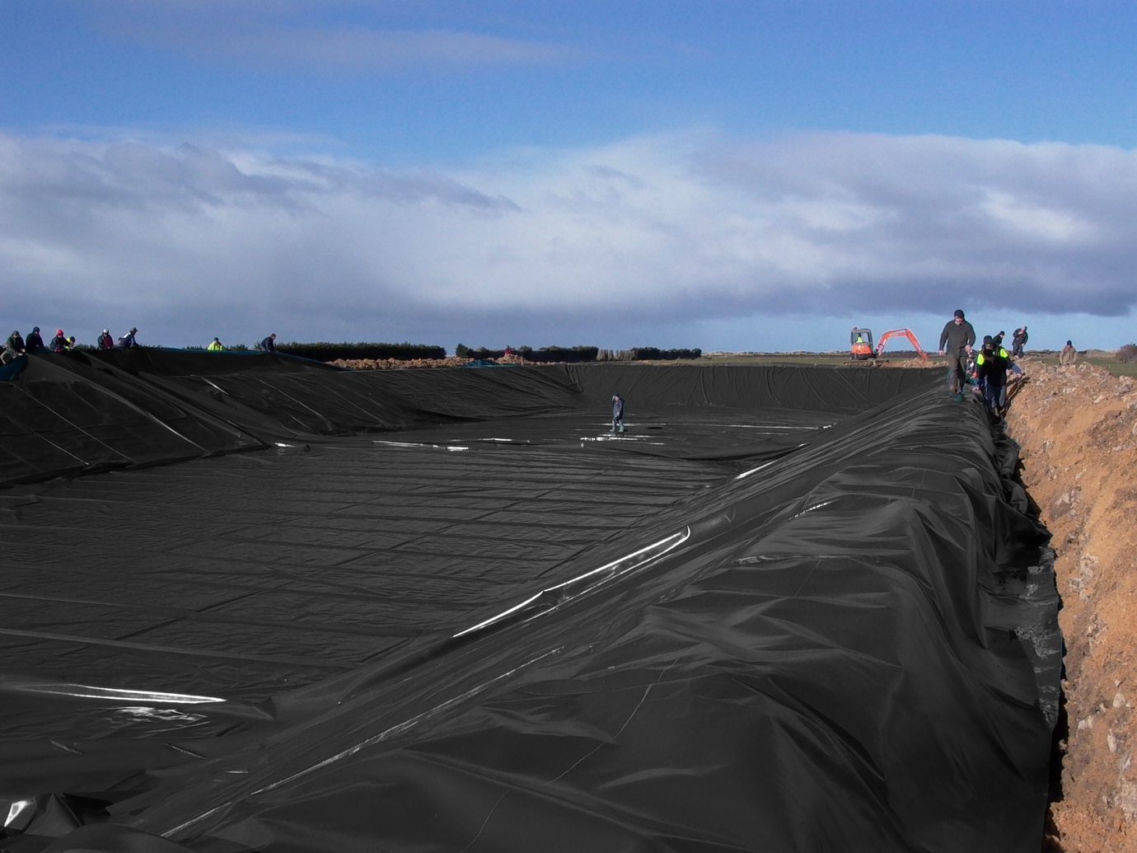

**Why Choose Aquamark®?**

**1. Superior Toughness and Low Permeability** Aquamark® is a PP-R liner engineered with a scrim-reinforced polypropylene coated fabric, ensuring exceptional toughness and low permeability. This combination is ideal for retaining gas and fluids, making it a versatile solution for a wide range of applications.

**2. Excellent Welding Characteristics** One of the standout features of Aquamark® is its excellent welding characteristics and wide welding window. This ensures a secure and reliable seal, enhancing the overall effectiveness of the geomembrane in containment applications.

**3. Certified Water Potable and UV-Stabilsed** Aquamark® +480 is certified to AS/NZS 4020 standards, making it suitable for potable water applications. Additionally, it is UV-stabilised, ensuring long-term durability and performance even under harsh environmental conditions.

**4. Flexible and Lightweight** Despite its toughness, Aquamark® is lightweight and flexible, making it easy to handle and install. This flexibility does not compromise its strength, allowing it to adapt to various shapes and configurations needed for different containment solutions.

**5. 15-Year Warranty** GALE Pacific stands by the quality of Aquamark® +480, offering a full 15-year warranty. This assurance provides peace of mind, knowing that you are investing in a product built to last.

**6. Sustainability** Aquamark® is PVC-free, and does not contain harmful chlorine, plasticisers, BPA, BPS and PFAS. Its is also recyclable, which helps reduce environmental impacts at end of life.

**Applications of Aquamark®**

Aquamark® is specifically designed for a wide range of water and effluent containment and storage applications. Its versatility makes it an excellent choice for:

* Dam and pond linings
* Tank liners
* Effluent containment
* Any application requiring reliable and durable containment solutions

**The GALE Pacific Advantage**

Manufactured in GALE Pacific’s Australian factory, Aquamark® is produced using a proprietary 3-layer, single-pass coating process. This advanced manufacturing technique ensures consistent quality and performance, reinforcing GALE Pacific’s commitment to delivering superior products.