When is CQA not CQA?

By GNA Editor

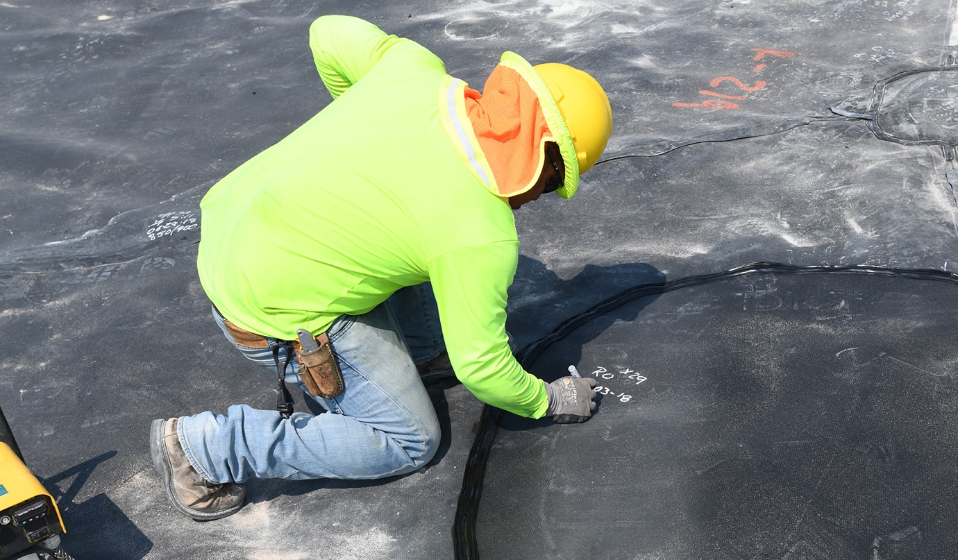

Independent third-party Construction Quality Assurance (CQA) should be done by an experienced consultant with thorough knowledge of geomembranes and seam performance characteristics who is appointed to verify that the works have been carried out to the agreed standards.

The duties of the third-party CQA consultant include inspections, verifications, audits and evaluation of materials and workmanship, provision of advice on installation, testing, repair, and covering of the geomembrane lining system and issuing a final CQA report documenting the quality of the constructed facility.

CQA thus plays a crucial role in ensuring the integrity and performance of geosynthetic installations, particularly in critical applications like landfills and containment systems.

Unfortunately, despite its critical nature, onsite CQA personnel often consist of junior staff lacking substantial field experience, essentially learning as they go. “A function of an experienced CQA Engineer is to make informed decisions based on the requirements of the specification, as well as their practical field experience. For example, determining the location and number of weld samples to inspect following a geomembrane seam failure”

Despite requirements for qualified and experienced CQA engineers, these roles frequently fall to new hires and recent graduates. The learning curve is steep.

The above can result in instances where CQA may not fulfill its intended purpose, potentially compromising project quality and safety. CQA is not truly CQA when:

1. Inexperienced personnel are deployed: Despite requirements for qualified and experienced CQA consultants, many projects utilize junior staff or recent graduates with limited field experience. This practice contradicts the need for personnel with extensive knowledge of geomembranes and seam performance characteristics for the various material types and profiles

2. Lack of proper qualifications: CQA engineers should be appropriately qualified civil or geotechnical engineers with at least 5 years of experience in landfill design and / or construction. When individuals without these qualifications are tasked with CQA responsibilities, the quality of oversight may be compromised.

When polymers and materials are modified the characteristics of the material and welding parameters change. As such the performance of the seams can be compromised if old installation criteria are used to determine the quality of the installation

3. Insufficient oversight: Effective CQA requires regular on-site monitoring and direct supervision. When there is inadequate oversight of junior staff or remote supervision without proper documentation and controls, the CQA process loses its effectiveness.

5. Inadequate experience for project size: CQA personnel should have experience commensurate with the project size. For instance, a CQA Site Representative should have worked on at least 2 projects with a minimum of 50,000m² of geosynthetics installation. When personnel lack this level of experience, the quality of CQA may be compromised.

6. Lack of independence: CQA consultants must be independent third parties, free from conflicts of interest with contractors or project owners. When this independence is compromised, the objectivity and reliability of the CQA process are called into question.

7. Failure to perform required duties: CQA consultants are responsible for various tasks, including inspections, verifications, audits, and material evaluations. When these duties are not fully carried out or documented, the CQA process is incomplete.

8. Inadequate decision-making: CQA often requires making subjective decisions, such as determining the number of weld samples to select after a failure. When inexperienced personnel lack the judgment to make these decisions effectively, the quality of the installation may be at risk. Failings of the site CQA to recognise the correct intent of the specifications can lead to incorrect directions and compromise of the geomembrane installation.

9. Lack of proper certification: In some jurisdictions, CQA engineers must be registered on the National Engineering Register or hold specific certifications like the Geosynthetic Certification Institute – Inspectors Certification (GCI-ICP). Without these credentials, the CQA process may not be recognized as valid.

10. Failure to prepare comprehensive reports: A key responsibility of CQA consultants is to issue a final CQA report documenting the quality of the constructed facility. When these reports are incomplete or not prepared by qualified individuals, the CQA process fails to provide the necessary assurance.

To ensure that CQA fulfills its intended purpose, it is crucial for project owners and regulators to enforce strict adherence to qualification and experience requirements. Implementing a structured oversight plan, providing ongoing training for CQA personnel, and maintaining clear documentation of supervision and decision-making processes are essential steps in maintaining the integrity of the CQA process.

By addressing these issues, the geosynthetics industry can work towards closing the gap between CQA requirements and actual practice, ultimately improving the quality and reliability of geosynthetic installations in critical environmental and engineering applications.

Conclusions

An independent third-party consultant specializing in geomembranes, well-versed in their performance characteristics and seam integrity, must be appointed to ensure that construction meets agreed standards. This consultant's responsibilities include conducting inspections, verifications, audits, and evaluating materials and workmanship. They also provide guidance on installation, testing, repair, and finalizing the geomembrane lining system, culminating in a comprehensive CQA report documenting facility quality.
The CQA needs to be involved at the outset of the construction to be a party to the group that will deliver the finished product, CQA inspector, Owner , Design engineer and Lining contractor , this way all stakeholders have an input to the project and the final delivery

Technical reports must be authored and signed by qualified and experienced individuals. For landfill design and major construction CQA documentation, this typically requires an engineer—such as a civil or geotechnical engineer—endorsed by Engineers Australia or equivalent, possessing at least five years of landfill design and construction experience, and currently practicing competently in this field.

Despite requirements for qualified and experienced CQA engineers, these roles frequently fall to new hires and recent graduates. The learning curve remains steep. With heightened quality standards, the demand for experienced onsite CQA personnel becomes crucial, given their significant influence on construction phase efficiency. As industries adopt new standards, adapting to efficiently implement these changes is imperative.

The industry is evolving with new challenges with new materials coming onto the market and it is important that the site inspection is familiar and experienced in new welding criteria, materials and iterations of the specifications to deliver the installation to the intended Design. Thus making site inspection CQA an important part of the complete delivery of any project.

