**PRESS RELEASE**

**Freudenberg expands global 3D entangled mat production with a new line in China**

**Weinheim, July 13th, 2023. Freudenberg Performance Materials (Freudenberg)**, **a leading global supplier of high-performance technical textiles has begun operating a new 3D entangled mat production line in Changzhou (China). It enables Freudenberg to supply customers in the APAC region with Enka®Solutions made in China for building, industrial and civil engineering applications. Freudenberg now is also able to serve customers in diverse technical markets with finished and semi-finished products.**

This investment in China will significantly increase Enka®Solutions production capacity and will play a fundamental role in the development of Enka business with customers in the APAC region. Freudenberg inaugurated the new line in Changzhou at an opening ceremony on July 13th.

**Faster and more efficient delivery**

The new production line in Changzhou complements the manufacturing operations in Obernburg (Germany) and Asheville (North Carolina, USA). With a global manufacturing presence on the three different continents Europe, Asia and America, Freudenberg can now serve markets locally and deliver Enka®Solutions products faster and efficiently. This will not only help to better meet customer needs, but also reducing the company's environmental footprint by increasing local production.

**About Enka®Solutions**

Freudenberg´s Enka®Solutions is a solution provider for high-performance 3D entangled mats and composites products that offer multiple solutions for building, industrial and civil engineering industries, contributing to sustainable and ecological development of urban construction.

Thanks to its unique 3D entangled polymeric filament structures, Enka®Solutions products efficiently answer challenges in the fields of acoustic, ventilation, drainage, erosion control, sports and recreation, vibration damping, soil reinforcement, bio-filtration and more.

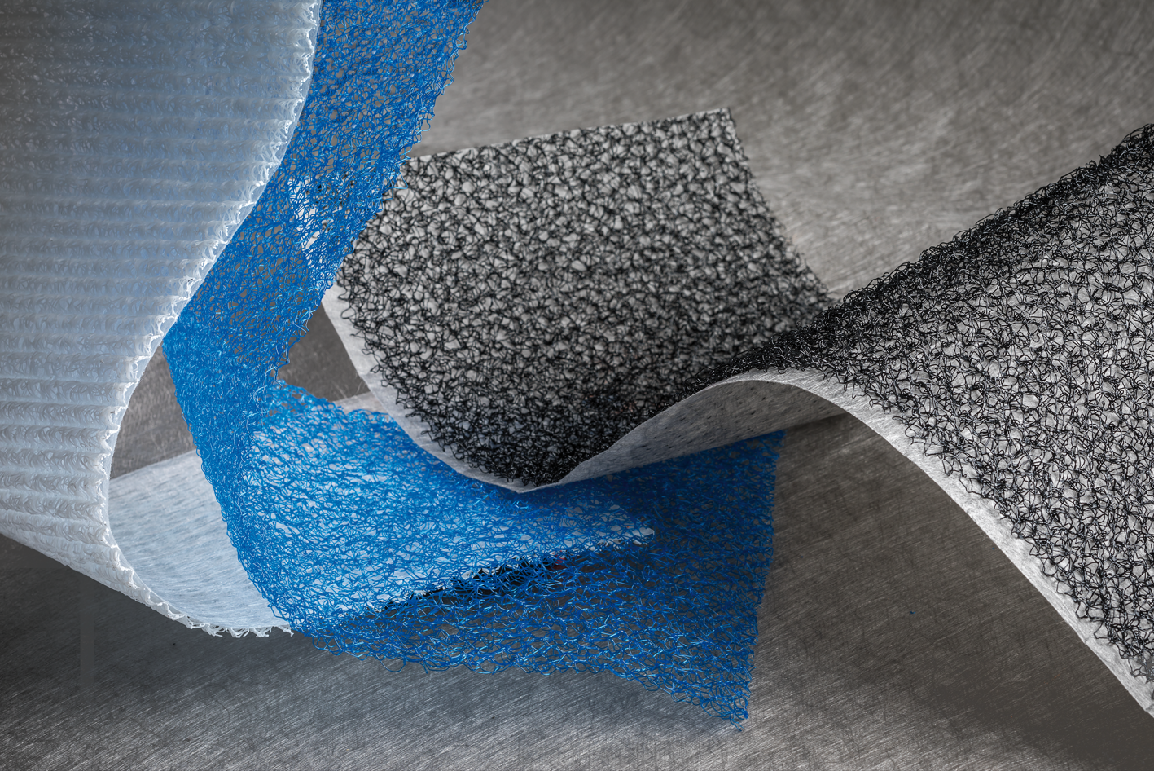

Contacts for media inquiries

Freudenberg Performance Materials Holding GmbH

Holger Steingraeber, SVP Global Marketing & Communications

Höhnerweg 2-4 / 69469 Weinheim / Germany

Tel. +49 6201 7107 007

Holger.Steingraeber@freudenberg-pm.com

www.freudenberg-pm.com

Katrin Böttcher, Manager Global Media Relations

Höhnerweg 2-4 / 69469 Weinheim / Germany

Tel. +49 6201 7107 140

Katrin.Boettcher@freudenberg-pm.com

www.freudenberg-pm.com

**About Freudenberg Performance Materials**

Freudenberg Performance Materials is a leading global supplier of innovative technical textiles for a broad range of markets and applications such as apparel, automotive, building interiors, building materials, healthcare, energy, filter media, shoe and leather goods as well as specialties. In 2022, the company generated sales of some €1.6 billion, had 32 production sites in 14 countries around the world and had more than 5.000 employees. Freudenberg Performance Materials attaches great importance to social and ecological responsibility as the basis for its business success. For more information, please visit [www.freudenberg-pm.com](https://eur02.safelinks.protection.outlook.com/?url=http%3A%2F%2Fwww.freudenberg-pm.com%2F&data=05%7C01%7CKatrin.Boettcher%40freudenberg-pm.com%7Cb842f96c332449e3846008db463194a9%7Cc7b0778106f341d7b40f5b2de1018509%7C0%7C0%7C638180950979533767%7CUnknown%7CTWFpbGZsb3d8eyJWIjoiMC4wLjAwMDAiLCJQIjoiV2luMzIiLCJBTiI6Ik1haWwiLCJXVCI6Mn0%3D%7C3000%7C%7C%7C&sdata=Z9Qqpb2bKguISzdIflVrbN0g2mD9qRU2HMGh9yoXy6Y%3D&reserved=0)

In 2022, the Freudenberg Group employed more than 51,000 people in around 60 countries worldwide and generated sales of more than €11,7 billion. For more information, please visit [www.freudenberg.com](https://eur02.safelinks.protection.outlook.com/?url=http%3A%2F%2Fwww.freudenberg.com%2F&data=05%7C01%7CKatrin.Boettcher%40freudenberg-pm.com%7Cb842f96c332449e3846008db463194a9%7Cc7b0778106f341d7b40f5b2de1018509%7C0%7C0%7C638180950979533767%7CUnknown%7CTWFpbGZsb3d8eyJWIjoiMC4wLjAwMDAiLCJQIjoiV2luMzIiLCJBTiI6Ik1haWwiLCJXVCI6Mn0%3D%7C3000%7C%7C%7C&sdata=kH5NQGuO0LOpwQ2PIXl2iez%2BBW%2Fx6R23TY23WFjHWQ8%3D&reserved=0).